**Undergraduate Final Year Project Proposal**

**Personal E-commerce management website application**

**Of**

**Retailer Store and general merchant.**

**THATSADAPHONE INTHAPAKDY**

**Computing – Software engineer**

**Student Id of Green UK: ti4587n**

**Student Id of Green Da Nang: GCD191062**

## Overview

Over the past decade, a Technology has been grown more and more nowadays, the applications are being used to improve work, trading as daily basic, and become very necessary. It essentially changed working systems as well as improved work output. Therefore, in case study of the E-commerce application as online shop management is critically necessary.

By this study, I would like to develop a market system as online shopping to address retail store issue. Including by (Sims, 2018) “Online marketplace is known as e-commerce stand for the process of buying, selling and exchange products or service by the internet and network system”. The trading of e-commerce is conducted including of online funds transfer, marketing, inventory system and online payment or transaction processing. The hug usage of e-commerce is showed totally for virtual product items. Example for access to item’s content on a Web application, which allow customer to select the items into cart for making Transaction process, while most e-commerce includes the transportation of physical items between Seller and customer. Furthermore, retailer store whose change to do e-commerce would be known as e-tailers of e-commerce presence on the world wide web.

In retailer’s effort, that are a lot of development which support to take full advantage of income, production and operation of businesses at main stores market, while have taken increase in difficulty of marketing system as well as “Business to Business” (B2B) and “Business to Consumers” (B2C) with its own operation.

By those sentences above, there are many problems at market system which include

* “Pressures Selling’s Day-to-Day”.
* Market share and Price Competitions.
* Can’t recognize visited customers
* Market availability.
* Not stable price.

However, online shop of e-commerce provide appropriate method for shoping without crowds on epidemic period. Online selling and buying have given new crossing tool to ease operation or transaction process, which is been implement for helping user to become more and more comfortable with online shopping. As increase pressure in shopping sites competition (Sims, 2018), most retailer must focus on pomotion of products and inspiration customer to shop on their store as making item available online. By this fact, almost retailers store have concept as well known as “Clicks and mortar to Home ”, which all retailer’s shop site must provide customer with easy to use features.

## Aim

This application will help “**Retailer Store and general merchant”** to solve some significances problem including of “payment cash”, “shopping anytime”, “transportation or delivery to home”, “Improve transaction of product”.

## Objectives

* 1. **Research Report**
     1. **Literature Review.**
     + **Qualitative research.**

**We will plan to Interview the local retailer store around city for surveying the current tail store’s situation including of collected order, delivery system of goods with overall of limited process.**

**The last interview, would like to organize interviewing with the store owner, factory’s CEO and online retail steamer about “How can online marketplace solve consumer’s search and demand for ease”, which we could find out the advantage and disadvantage point of online marketplace on the limitation of transaction e-commerce.**

* + - **Quantitative research.**

We will provide a survey with store seller and customer across the local area of city, which those should be conducted to determine the accessibility of online marketplace and each requirement can be conducted by specific functionality checklist with counted numbers. So, the survey report will be generated the static chart of percentage pie such as google survey.

* + 1. **Development investigation**
* **Web Application**

**This project will be sing ReactJS to create interactive UI with MongoDB for development to ensure stability and an improved UX.**

* **API service.**

**Study the developing Rest API as deploy live application with React and how to take part of method into the development application.**

* **Online Payment system.**

**To save time and effort with traditional method, the app would use online payment method in making transaction settlement for purchasing retail store’s item. As a result, we must study how this payment system technology can be combined into a web application.**

* 1. **Requirements.**
* **Data Collection.**
* **Interview the local retail store which able to figure out the performance of online marketplace process.**
* **Interview store own about the order system with payment method to delivery product in process.**
* **Collect the data condition of store market in real-time activity, the number of product items, categories, delivery order, the number of the purchased product which have paid online.**
* **Collect a critically data about lasted orders have been made, payment receipts calculation.**
* **Survey.**

**Survey the tail store own’s feelings during the product promotion and transaction process. This wed application is** **especially used by the store owner, retailer merchant, influent review steamer and reporting deliver order list with offer the transaction to process.**

* **Analyse user.**

**We would like to design web app that efficiently satisfied performance and improves the user experience or UX depend on hugest share of chart of user demand need which more feature must have in requirement.**

* 1. **Product Design.**
     1. **Design.**
* **Use-case Diagrams:**

To design the diagram, that procedure contributions in displaying the important feature requirements for online marketplace apps, which allow user developer to see what functional features including in the web app with how usage application.

* **ERD (Entity Relation Diagram):**

ERD contains the build in blueprint for implementing the app’s data procession of database and defining each model attributes with include relationships data in the online marketplace application.

* **Data Flow:**

We use put on overview of the system operation and data transmission between application’s functionality which step-by-step.

* **Identify Actors:**

We have to provide the description detail on the object and user whose role would interact with online marketplace application.

* **Definition of User Case:**

Define appropriately the main functionalities of app need and the flowed activities. Furthermore, this help to determine develop how between merchant and customer user can be engage on **transaction** with online market tool.

* **Use-case’s Actor Mapping:**

This should give out the overall interaction between the association merchant and the person in online market application.

* **Wireframes Design and Prototypes (Figma, Draw.io, etc.):**

We must design the web app’s page the overall layout and structure, which provide the presence by UX/UI. Also, we can specify the user's feature and component interaction as known well as animate simulation, that follow for improving the online marketplace application.

* **Product Feature development.**

1. Login authentication (Must)
2. User admin (Must) Overall management and Profiles.
3. Order management (Must) Create/Detail/Delete/Notification
4. Marketing Activity (Should)
5. Cart list item (Must) Add/Order/Purchase/Pay
6. Search product (Must)
7. Wish Cart (could) Add/Order
8. Product management (Must) Add/Edit/Delete/Detail
9. Payment method system (Must) Add Method/ Pay
   1. **Development and Testing.**

* **Implement Developing.**

The online market application will be starting development for 12 months to whole the deadline.

* **Deploy Git Repos in “Netlify”.**

**We decide to deploy the main app’s folder as GitHub repository by link Git’s URL in “Netlify”, this deployment will make the online market application run in online real-time.**

* **UI/UX.**

**After testing the UI/UX design in the online market application, we wish to construe its more naturally interactive with easy to use, but mostly fucus on main function such chart, order, payment method.**

* **Testing evaluation**

**This system will be built for the retail store and general merchants in transaction management, the production web app should be passed to experts of marketing with business major and retail store. So, they can apply testing and give the result of reliable test about viewpoint of promotion broker and natural user.**

## Legal, Social, Ethical and Professional

* 1. **Legal.**

Online marketplace is a trading goods system that is common nowadays, but, as one of e-commerce web-based application while involves a lot of legal issue by (Massoud, 2002) including of such as validated contracts of goods agreement, authority over trading and Encoding policies. Therefore, I have research on this issue that nowadays e-commerce has the opportunity allowed to do free-trade with copyright by selling as a retailer-store for improvement of country's economy.

* 1. **Social.**

According to (Hajli, 2012), E-commerce keeps having more and more impacts on the future generation of business approaches by marketing explore, which suggestions new tools to force for economy innovation. E-commerce also have been moving customer behaviour by do transaction online with storing application. Therefore, we can apply this online marketplace to through research on e-commerce adoption with marketing approaches.

* 1. **Ethical.**

According by (Massoud, 2002), there have provided that most of “the educated users such as age more than 20 years old, they are professed about the most issues of privacy info and unfair transaction by be scammed on the online trading”. For example, based on research background, the user feels comfortable by seeing other product’s copyright symbol, also other hand of uncomfortable when online app has asked to provide more info about goods of user’s right for authentication such as cookie, much advertisement and Product origin.

By this issue above, it can prove that users tend to not use the online shop application of concerned about the legality and the ethical issues on which kind of goods or product’s brander. Well, this online marketplace application has activity about transaction between retail-store merchant and direct customer. So, this issue can be solved by asking user for agreement in term of condition of trading as a retailer as well as the general merchant. Such some condition of rules as If users whose have posted a duplicated product, but allow them to post because they can influent more customer to attend more products with the same or different prices.

* 1. **Professional.**

professionally, the application will be secure for user’s info of the merchant and shopper. In addition, only atomisation officer in charge of app’s IT department and operation department are allowed according to (Sims, 2018) have the authority to access user info with the promises law to not definitely release user’s personal info to the third party. Also, the scope of this study that look into the processes which are involved in marketing place of products and service operation. We as researchers are professionally focus on the operation system and support such as adversity product, general activity like sale, process of payment transaction in our app and network, which this app can only provide user a service operation of shopping with secured privacy or policy guiding on sales.

## Planning by Gantt Chart.

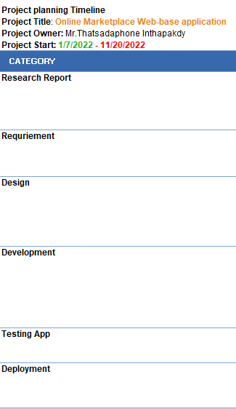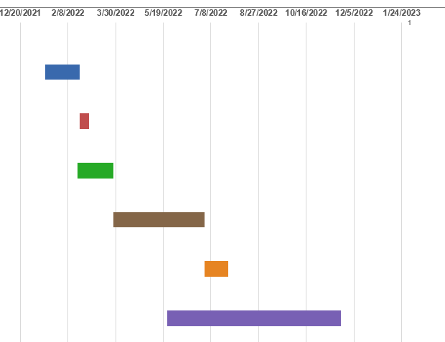

## Initial References

Hajli, M., 2012. An Integrated Model for E-commerce Adoption at the Customer Level with the. *International Journal of Information Science and Management,* Issue ECDC 2012, p. 79.

Massoud, S. L., 2002. *ETHICAL AND LEGAL ISSUES IN E-COMMERCE,* s.l.: Prairie View A&M University.

Sims, L., 2018. *Building Your Online Store With WordPress and WooCommerce: Learn to Leverage the Critical Role E-commerce Plays in Today’s Competitive Marketplace.* s.l.:s.n.